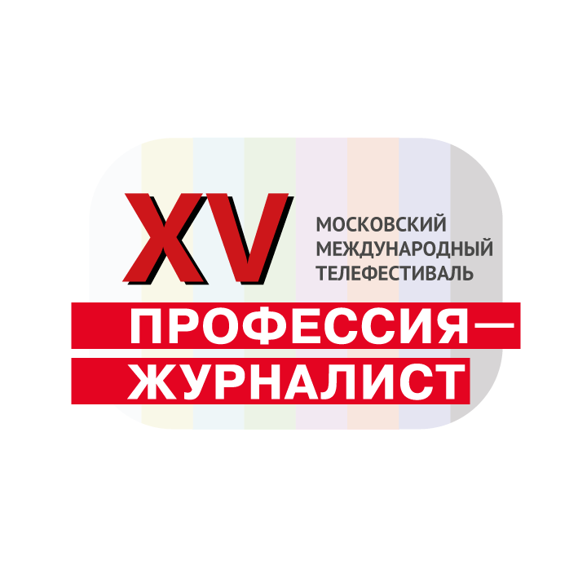

The XV Moscow International TV Festival

REGULATION

About TV festival

Date and location of holding: November 2023, Moscow

Main objectives of the TV festival:
- Popularization and raising prestige of “journalist” profession, comprehension of its role in modern society and encouraging authors of works about journalists;

Clause 2. Organizer

The Film Directors’ Guild of Russia with the support of the Department of mass media and advertisement of the city of Moscow.

Clause 3. Terms of participation
​
Cinematographers and journalists, staff members and non-staff members of federal and regional editorial boards and TV channels, independent producers of media-content, students of journalism departments are invited for participation. Materials telling about journalists’ work and produced in 2022-2023 are admitted to take part in the competition

The key criteria – explosion of the theme
​
The following documents should be presented for participation in the competition:
- application form of a participant, that should be certified by a right holder and should contain the following information: work’s summary, author’s biography, list of creative works, telephone number, fax number, email address;
- one participant can submit one work;
- director’s or author’s photo;
- shot of film, TV program, report;
- with expansion MP4 (possible – mov or mxf). Reference to downloading of video file is .allowed;
- Duration of work is limited up to 52 minutes;
- Works that already participated in other festivals can take part in the competition.
​
Works for participation in the completion can be submitted from 1 May to 15 September 2023 .
A Special Certificate will be given to each participant of the TV festival.
Works submitted to the competition are not returned to authors.

Clause 4. Competition
​
- Documentary films only about journalists’ work;
- TV programs;
- Reports of journalists’ work;
- TV stories about journalists.

Clause 5. Jury
​
Works will be evaluated by the Jury. The Jury is composed of professionals in cinematography and TV, journalists working in various genres.

Clause 6. Prizes

Prizes are given in the following nominations:
- The best documentary film;
- The best TV program;
- The best report;
- The best TV story;
- Prize of viewers’ sympathy;
- Prize “Professional Recognition”.
​
Clause 7. TV festival program
​
- Competition program;
- Information program;
- International program.

Clause 8. Our address

Moscow 123056, 13, Vasilievskaya str., Office офис 43
The Film Directors’ Guild of Russia
To the completion “PROFESSION-JOURNALIST”
Telephone: +7 (925) 290-33-30
TV festival site: journfest.ru
e-mail: konkurs-pj@mail.ru

